 | 2nd Annual International Conference on Technology & Engineering, 22-25 June 2015, Athens, Greece
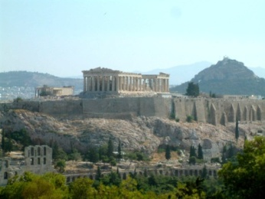 |  | CALL FOR PAPERS | 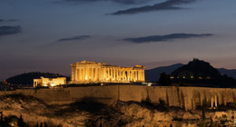
The Engineering and Architecture Research Division of the Athens Institute for Education and Research (ATINER) organizes a cross discipline conference on Technology and Engineering. For further details, please go to the conference website: http://www.atiner.gr/technology.htm. The aim of the conference is to bring together academics, researchers and professionals in areas of technology, engineering and other related disciplines. You may participate as panel organizer, presenter of one paper, chair of a session or observer. Please submit a proposal using the form available (http://www.atiner.gr/2015/FORM-TEN.doc).
Academic Member Responsible for the Conference:
- Dr. Gregory T. Papanikos, President, ATINER & Honorary Professor, University of Stirling, U.K
- Dr. Panagiotis Petratos, Vice-President of Information Communications Technology, ATINER & Fellow, Institution of Engineering and Technology& Associate Professor, Department of Computer Information Systems, California State University, Stanislaus.
- Dr. Nicholas N. Patricios, Director, Engineering & Architecture Research Division, ATINER, Professor & Dean Emeritus, School of Architecture, University of Miami, USA.
- Dr. Theodore Trafalis, Head, Industrial Research Unit, ATINER & Professor of Industrial and Systems Engineering, The University of Oklahoma, USA.
- Dr. Thomas Attard, Deputy Head, Architecture & Engineering Research Unit, ATINER & Associate Research Professor, Arizona State University, USA.
Important Dates:
- Submission of Abstract: 1 May 2015 2015
- Acceptance of Abstract: 4 Weeks after Submission
- Submission of Paper: 18 May 2015
The Social Program Includes:
- A Greek Night of Entertainment with Traditional Greek Dinner (the place offers panoramic view of the Acropolis Hill and the illuminated Parthenon).
- An Urban-Archaeological tour of Athens. Among other sites, it includes: Zappion, Syntagma Square, Temple of Olympian Zeus, Ancient Roman Agora and on Acropolis Hill: the Propylaea, the Temple of Athena Nike, the Erechtheion, and the Parthenon.
- Special one-day cruise to selected Greek islands.
- One-day visit to Delphi.
Conference Fees
Participants have the following fee choices:
- €400 (euro) covering access to all sessions, two lunches, coffee breaks and conference material.
- €500 (euro) covering 2 nights of accommodation at the conference hotel with breakfast and all taxes paid, access to all sessions, two lunches, coffee breaks and conference material.
- €1000 (euro) covering 4 nights of accommodation with breakfast and all taxes paid, participation in all social and educational activities of the first and second day of the conference (Greek Night, Urban Walk & Dinner), access to all sessions, two lunches, coffee breaks and conference material.
- €2000 (euro) covering 4 nights of accommodation for two people in a luxury room at the conference hotel with breakfast and all taxes paid, transportation from/to the airport, transfer service for the first two days of the conference, participation for two people in all social and educational activities, access to all sessions, two lunches/person, coffee breaks and conference material.
The Athens Institute for Education and Research was established in 1995 as an independent world association of academics and researchers. Its mission is to become a forum where academics and researchers from all over the world could meet and exchange ideas on their research and discuss the future developments of their discipline. Athens was chosen as the meeting place because of its long history and culture.

